In Remote machine:

Step 1)Go to root user: sudo -i

Step 2)Run the command to install ansible: yum install -y ansible

Step 3)To make sure both the remote and slave nodes are communicating do the followng setup

vi /etc/hosts

enter the internal ip of node machines after the 3rd line

here 10.128.0.4 is the ip of remote machine

10.128.0.5 ansiblenodeagent1 [ip address nodeagentname]

10.128.0.6 ansiblenodeagent2

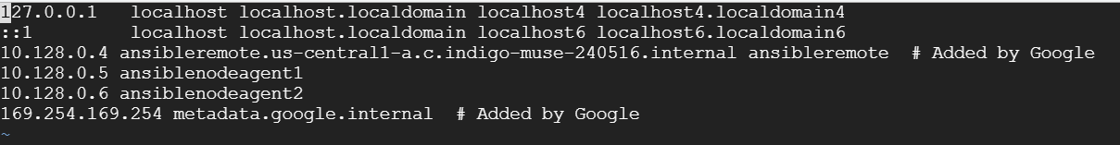

Step 4: To create server group in inventory file:

vi /etc/ansible/hosts

create a group and enter the ip addresses

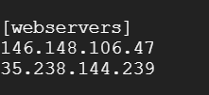

Step 5: Create an user with same name in remote and node machines.

Note: Do the same in node machines also

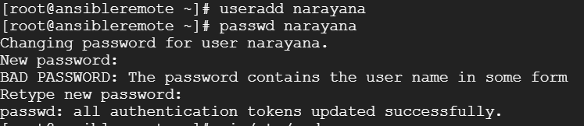

Step 6: vi /etc/sudoers

Enter the below at the end of file

narayana ALL=NOPASSWD: ALL [here narayana is the username created above

Note: do the same in node machine also



Step 7: vi /etc/ssh/sshd_config

set PasswordAuthentication to no

then run the command systemctl restart sshd

Note: Do the same in all node machines also

Step 8: Generate the ssh key in remote machine and copy it to node machines

Switch to created user

Run the command: ssh-keygen

It will generate a key

Then run the command to copy it to slave/node machines:

ssh-copy-id nodemachineuser@externalipaddressofnodemachine

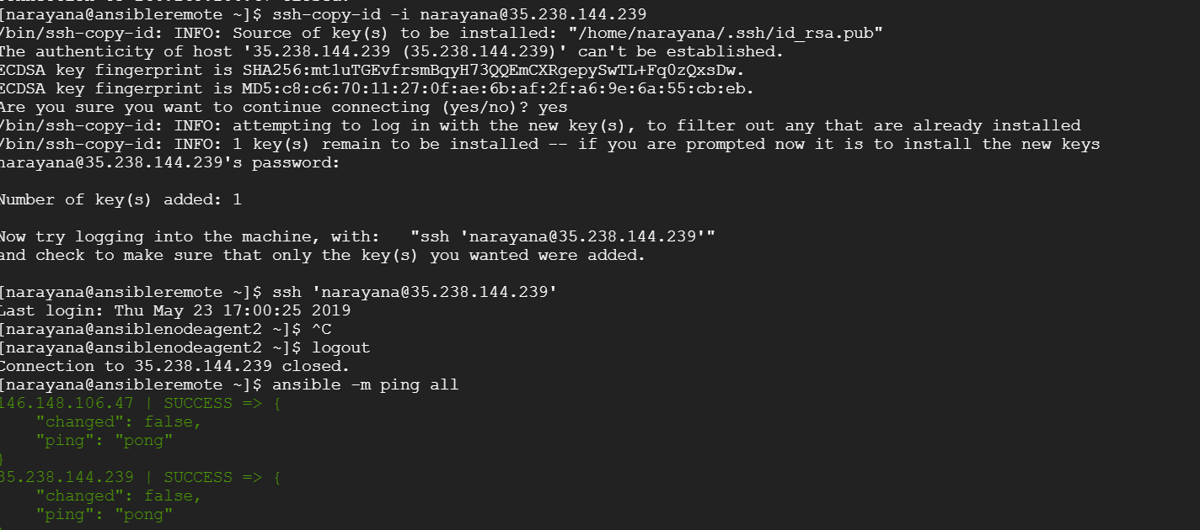

To check the connection established run the command: ansible -m ping all

You will see the green color above message in the screenshot if it is success